**Task 1: Server Deployment & Security**

**Objective -** Deploy the Spring Boot app on an Ubuntu server with HTTPS and auto-restart capabilities.

**1. Server Setup**

* Ubuntu 24.04 LTS VM on AWS.
* SSH into the server:

ssh -i "myapp-key.pem" ubuntu@43.205.189.41

**2. Install Java**

sudo apt update

sudo apt install openjdk-17-jre-headless -y

java -version

**3. Upload Application**

Copy the Spring Boot jar to the server:

scp -i "myapp-key.pem" HelloWorld.jar ubuntu@43.205.189.41:/opt/myapp/

**4. Create systemd Service for Auto-Restart**

sudo tee /etc/systemd/system/myapp.service >/dev/null <<'EOF'

[Unit]

Description=Spring Boot Application (myapp)

After=network.target

[Service]

User=ubuntu

WorkingDirectory=/opt/myapp

ExecStart=/usr/bin/java -jar /opt/myapp/HelloWorld.jar

Restart=always

RestartSec=5

SuccessExitStatus=143

[Install]

WantedBy=multi-user.target

EOF

sudo systemctl daemon-reload

sudo systemctl enable myapp

sudo systemctl start myapp

sudo systemctl status myapp --no-pager

**5. Install Nginx & Configure Reverse Proxy with SSL**

sudo apt install nginx -y

# Create self-signed certificate

sudo openssl req -x509 -nodes -days 365 -newkey rsa:2048 \

-keyout /etc/ssl/private/myapp.key \

-out /etc/ssl/certs/myapp.crt

# Configure Nginx

sudo tee /etc/nginx/sites-available/myapp >/dev/null <<'EOF'

server {

listen 80;

server_name _;

return 301 https://$host$request_uri;

}

server {

listen 443 ssl;

server_name _;

ssl_certificate /etc/ssl/certs/myapp.crt;

ssl_certificate_key /etc/ssl/private/myapp.key;

location / {

proxy_pass http://localhost:8080;

proxy_set_header Host $host;

proxy_set_header X-Real-IP $remote_addr;

proxy_set_header X-Forwarded-For $proxy_add_x_forwarded_for;

proxy_set_header X-Forwarded-Proto $scheme;

}

}

EOF

sudo ln -s /etc/nginx/sites-available/myapp /etc/nginx/sites-enabled/

sudo nginx -t

sudo systemctl restart nginx

**6. Test Application**

* **Public IP HTTPS URL:** https://43.205.189.41/hello
* **Expected response:** Hi, I am running from AWS Ubuntu Instance!!
* **Curl test (server or local machine):** curl https://43.205.189.41/hello --insecure

Note: Browser shows “Not Secure” because the certificate is self-signed.

**7. Firewall & Port Check**

* **Ensure port 443 (HTTPS) is open in the AWS Security Group.**
* **PowerShell test:** Test-NetConnection -ComputerName 43.205.189.41 -Port 443

**8. Verification Screenshot / Output**

* **URL run on browser:** [**https://43.205.189.41/hello**](https://43.205.189.41/hello)
* **Expected Output:**

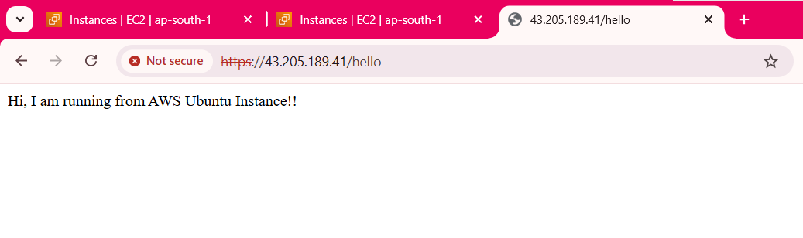

**Deliverables**

* **Public API URL:** [**https://43.205.189.41/hello**](https://43.205.189.41/hello)
* **Setup steps:** As documented above.